**FIELD TRIP CUM STUDENT’S EXCHANGE PROGRAMME**

**Department of Botany, Lunglei Government College**

**Objectives of the Field Trip:**

1. To study the vegetation around Thenzawl Village especially the Gnetum gnemon, locally known as ‘Pelh’ in Mizo which is said to be present only South to Thenzawl in Mizoram.
2. To visit some important places like Vantawng khawhthla, Deer park, Dilpui, Chawngchilhi Puk located in Thenzawl.
3. To exchange knowledge and learning strategies with the students of Botany core students, Government Serchhip College.

**Outcomes:**

Gnetum gnemon is the plant belonging to the family Gnetaceae and is native to North East India, China and South East Asia. Gnetaceae is said to be the bridge of Angiosperm to Gymnosperm as it possess both Angiosperm features like its leaves structure and Gymnosperm features like bearing male cone, fleshy strobili, etc.

The reason that Gnetum was found only at the south side of Mizoram is still unknown till date, but it was believed that, the habitat of this plant may be one of the factor as this plant is mostly grow on moist tropical forest. This topic remains one of the most interesting topic.

**FIELD TRIP REPORT:**

In morning of 7th April, 2023, Eleven students of Botany core students under the guidance of Sir Dr. Lalfakawma and Sir Vanlalreia Ralte, we headed Gov’t Serchhip College directly and we were welcome by Faculties of Botany Department, Serchhip College at around 10:00 O’Clock. After having interaction and Student’s Exchange session, we visited various places of Thenzawl such as Deer park, Dilpui, Vantawng khawhthla(the highest waterfall in Mizoram, 99 metres), etc. We returned to Lunglei, our hometown at sunset.

**Documentary Photos:**

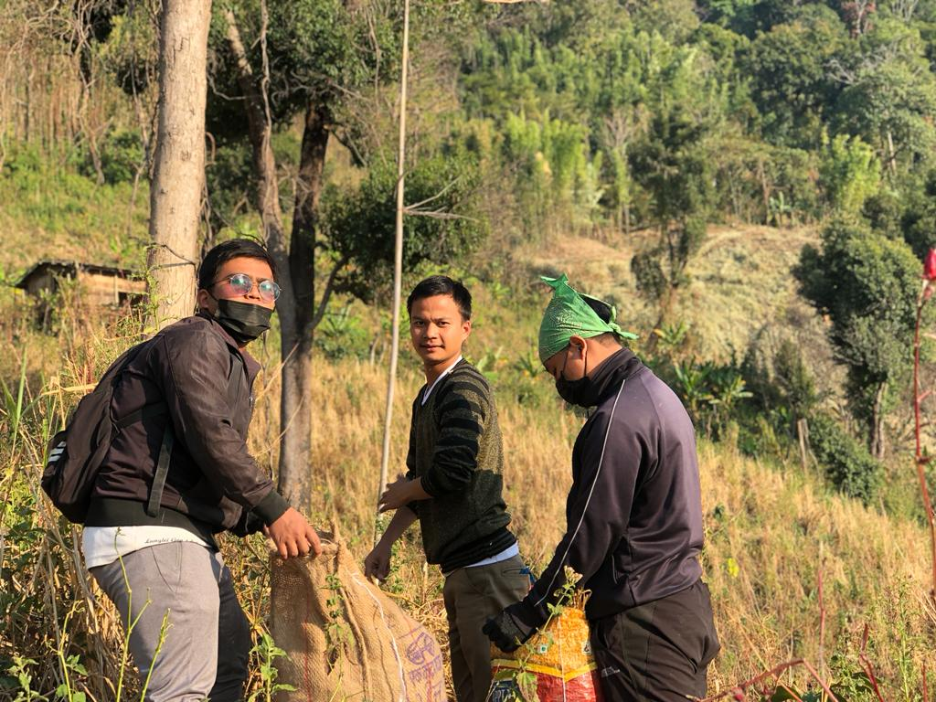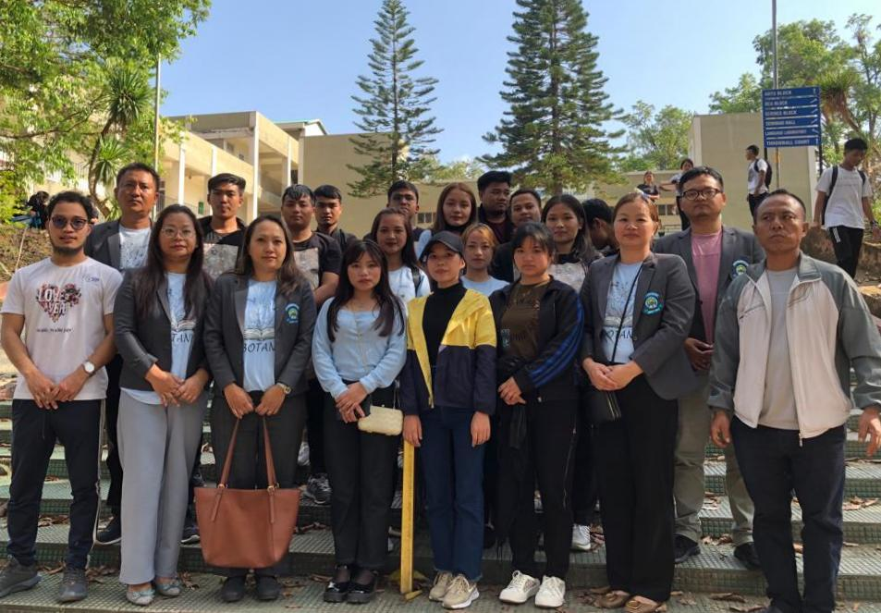

**Collecting Rice straw for Mushroom cultivation**

**Join Photo-session with Serchhip College**

