**1. Award received during 2019-2020**

**Blood donation-(Institution Category) for donating highest number of blood (units) during 2018-19**

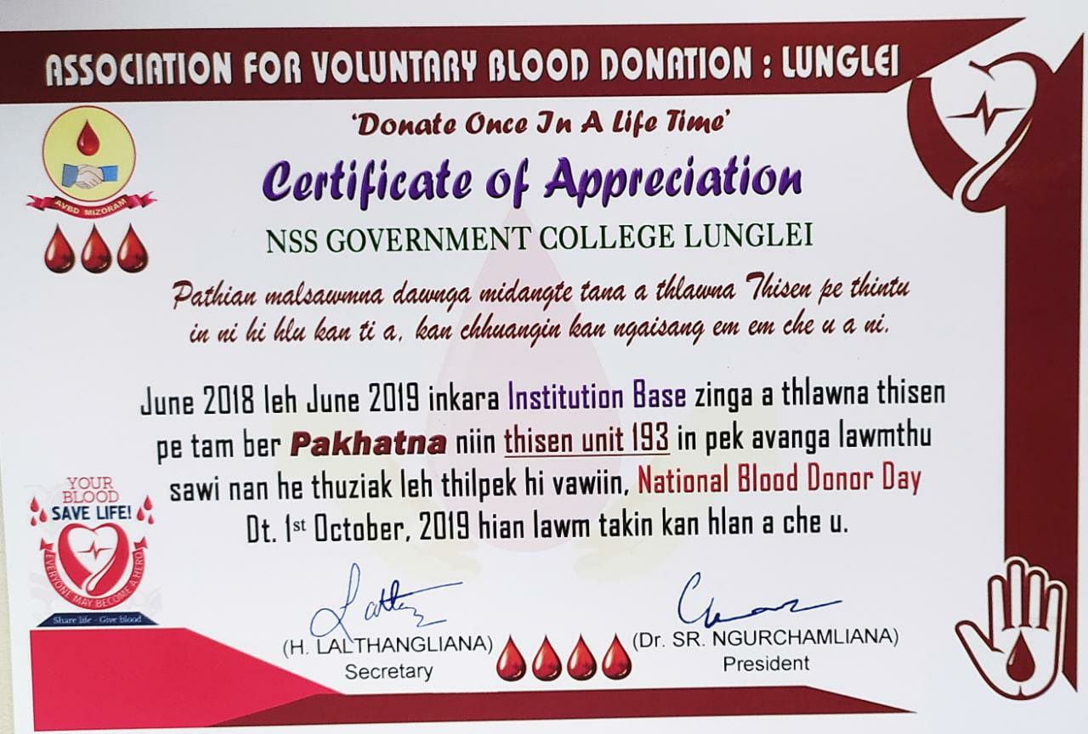

**2. Award received during 2020-2021**

**(1) 3rd Prize for Blood Donation**

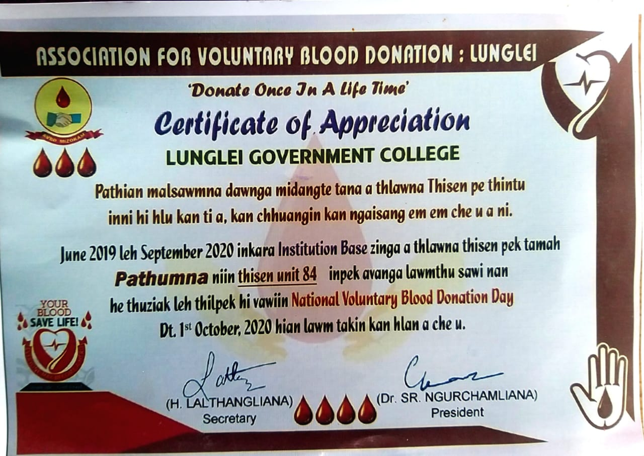

**(2) State NSS Award**

**Programme Officer (Mr. Lalrochama NSS Unit, Lunglei Govt. College)**

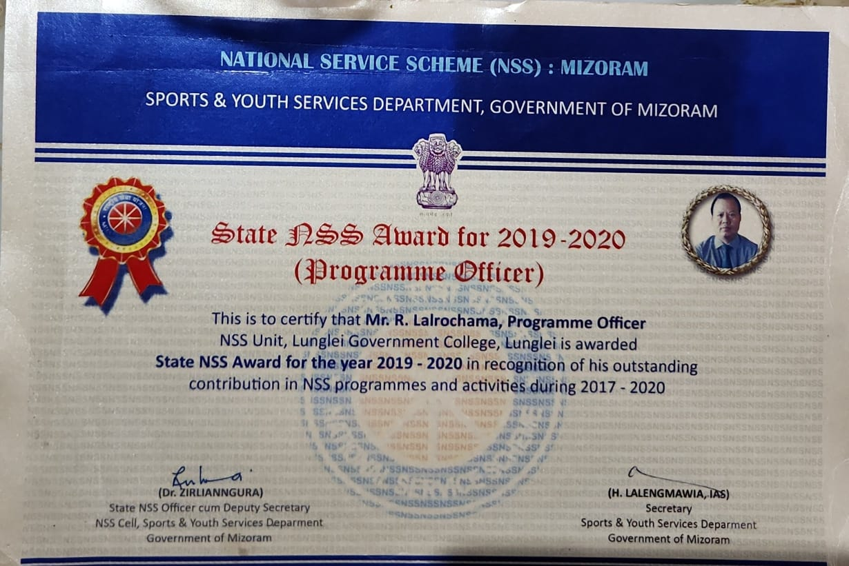

**(3) Sports Minister's Trophy in voluntary Blood Donation for 2020-2021**

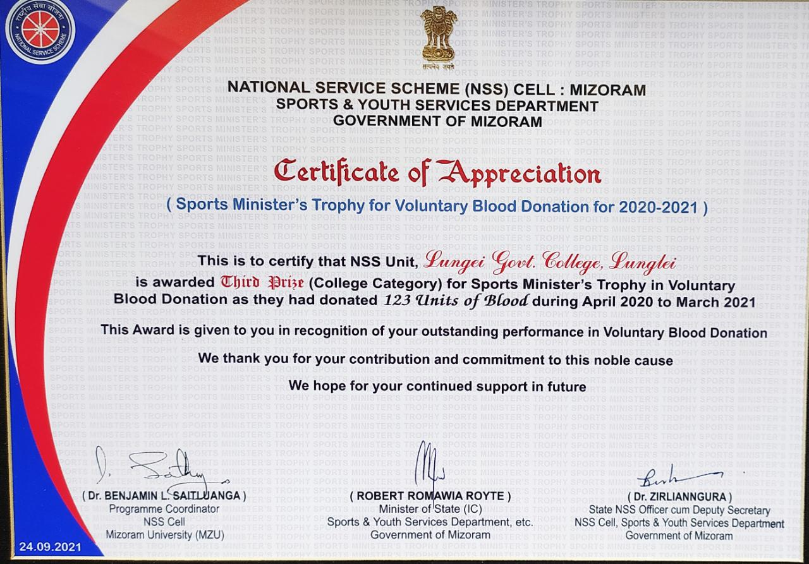

**3. Award received during 2021-2022**

**(1) Cleanliness Competition 2022**

