**NCC, LUNGLEI GOVERNMENT COLLEGE**

1. 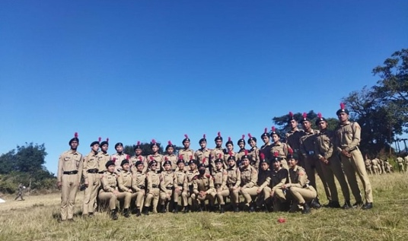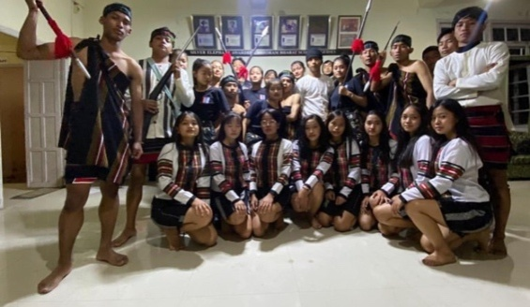Dt 8-17.12.2021:Combined Annual Training Camp was held in Tanhril. Every year, a mandatory camp is held for all cadets, and 33 cadets participated in this training. NCC activities like as drill, shooting, map reading, weapon training, first aid, and so on are included in the training, as well as games, cultural activities, and educational activities.
2. Dt 7.6.2022:21 Cadets participated in a tree planting effort at Zobawk, near the source of the Tlawng River. A total of 60 seedlings were planted, including Micheliachampaca, Cinnamomum verum, Bauhinia variegate, and Prunus Puddum.

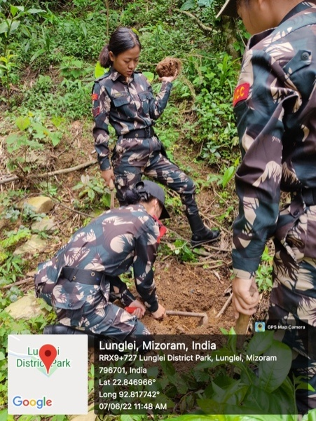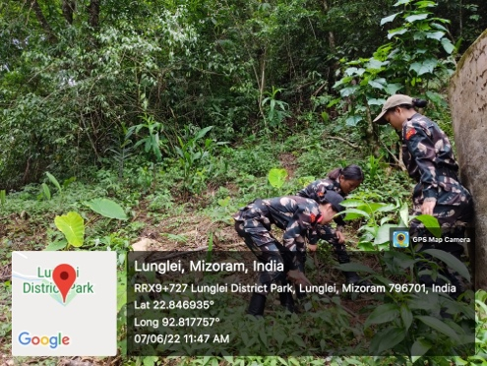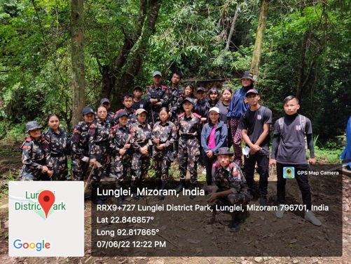

1. Dt.8.6.2022:Four Cadets participated in a contribution to Bethel Centre, a homeless residential care facility. The cadets provided clothing and a little sum of money to the caretaker.

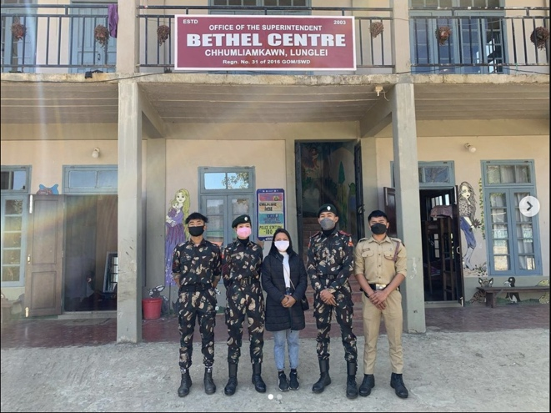

1. Dt.26.6.2022:To honour International Yoga Day, a 30-minute yoga practise was held at the RUSA Hall at 1:30 p.m. This event was attended by 20 Cadets.

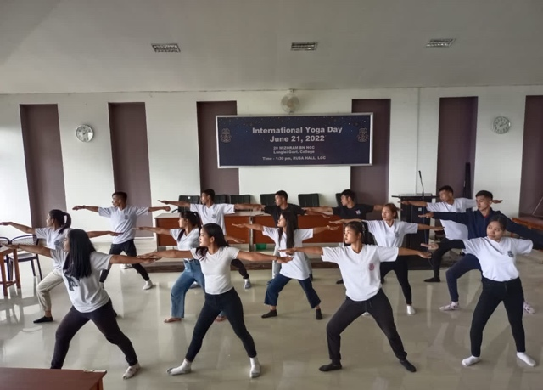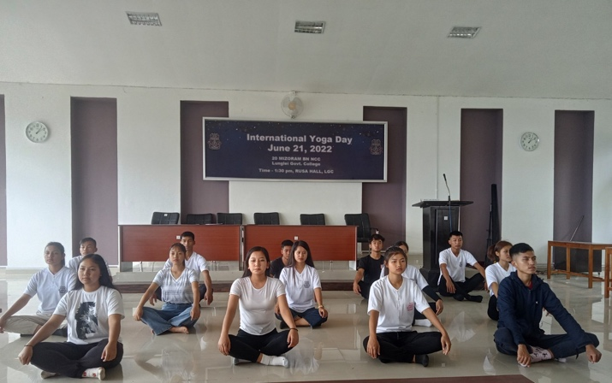

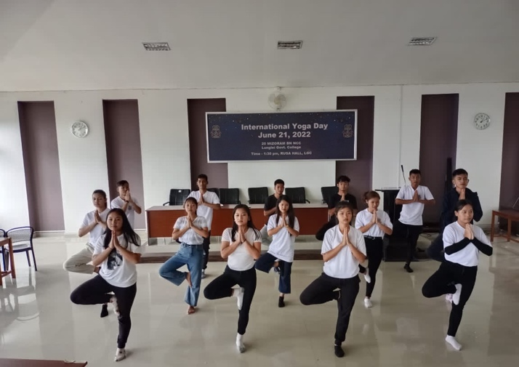

1. 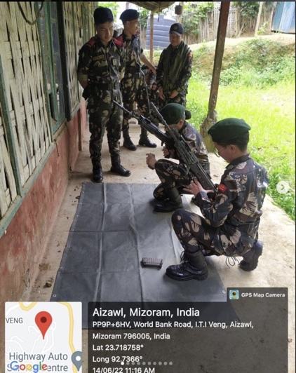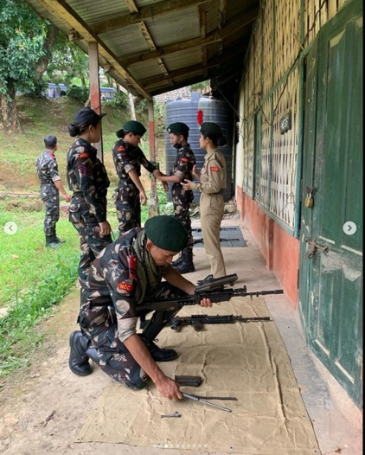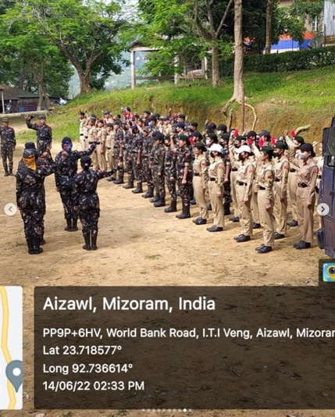Dt.14.6.2022:NCC Unit, Govt. Hrangbana College, and 3 Battalion MAP, Luangmualorganized a weapons training programme. Six Cadets represented our unit and learned the fundamentals of handling weapons such as 7.62mm SLR,7.62mm LMG,5.56 INSAS,5.56 INSAS LMG,7.62AK, and 9mm Pistol.